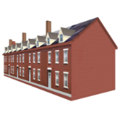

The Elfrida Society 34 Islington Park Street London N1 1PX Phone: 020 7359 7443 Fax: 020 7704 1358 www.elfrida.com

Phone No:

YES NO

Do you have a learning disability

Date of birth

Please give as much information as you are comfortable with.

If you would like help, please call the Sports Project on

020 7359 7443 or email: [enfrida@elfrida.com](mailto:enfrida@elfrida.com)

When answering a question, please circle either YES of NO

**Your Contact Details**

Address

Name

**Emergency Contact Details**

Name

Phone No:

Can we ask them for more information

YES NO

**Your Doctor’s Contact Details**

Your GP’s Name

Address



Phone No:

**Your Safety**

Is there anything we should know to keep you and others safe?



**Your health**

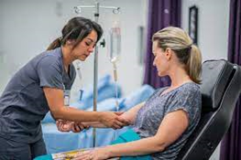

Do you have a heart condition?

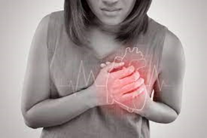

Do you have chest pain when you exercise?



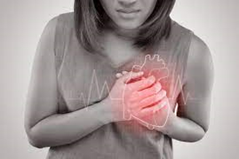

In the last month, have you had chest pain when not exercising?



Do you lose your balance because you feel dizzy?

Do you ever pass out?

**Your health continued**

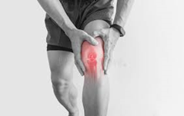

Do you have a bone or joint problem that could be made worse by exercising?

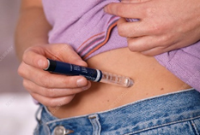

Do you have diabetes?

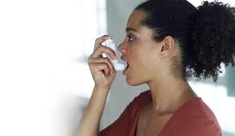

Do you have asthma?

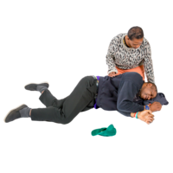

Do you have epilepsy?

Do you have any other conditions we should know about?

**You must speak to your GP if you answered yes to any of these questions. They must give you a letter saying you can do the sport or activity. We must have this letter before you start.**

**Your medication**

Do you take any medication?

**If you do take medication, please tell us about it here**



Type of medication

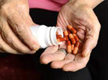

How much do you take?

When do you take it?



**Allergies**

If you have any allergies, please tell us about them here

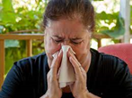

**Your Support**

What support do you need with travel, changing and doing sports or physical activity



Please circle all the ones you might be interested in

**Which Sports or Activities would you like to do?**



Cricket

Tennis

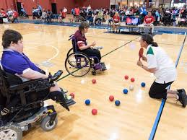

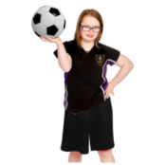

Football

Boccia

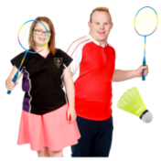

Badminton

Walking

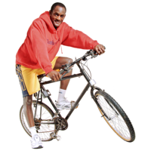

Cycling

Netball

Please tell us about other sports and activities you might be interested in

Date:

Signature:

Referred by

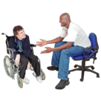

Relationship:

Date of referral:

**Keeping my details safe:**

|  |
| --- |
|  |

There are clear rules about how organisations keep people’s personal information. These rules are called the General Data Protection Regulations or GDPR.

The rules give people rights about how organisations keep their personal information.

The Elfrida Society is fully committed to follow the GDPR rules and procedures to ensure that the rights of its service users, staff and volunteers are protected. Everyone working with the organisation must obey these rules and procedures.

Personal information is information that can be used to identify you.

This includes:

Your name

Your address

Your telephone number.

Your email address

Links to your social media accounts like Facebook, Twitter or Instagram

Information about your disabilities or health

Your bank details.

Your employment records or information

I understand that The Elfrida Society will need to keep my personal details according to data protection rules.

Please tick to agree.