**Volunteer Application Form**

Thank you for wanting to volunteer at the Elfrida Society.

We would like to get to know about you.

Please give as much information as you are comfortable with.

If you would like help, please contact Dolly Galvis on 020 7359 7443 or email: [dolly.galvis@elfrida.com](mailto:dolly.galvis@elfrida.com)

We will need to keep the information you give us on this form. We will keep it private and safe.



**Your Contact Details**

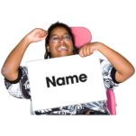

Name

Email



Phone No:



Address

Are you autistic?

YES NO

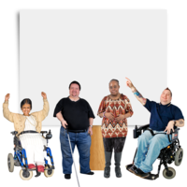

YES NO

Do you have a learning disability?

Please answer the questions below

and write your answers in the boxes.

What is the volunteering role you are interested in?

……………………………………………………………………………………………………………………

What interests, skills and hobbies do you have that makes you the right person for this volunteering role?

…………………………………………………………………………………………………………………………………………………………………………………………………………………………………………………………………………………………………..…………………………………………………………

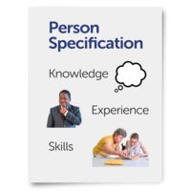

Have you done any volunteering in the past? If so, please tell us about it.

………………………………………………………………………………………………………………………………………………………………………………………………………………………………………………………………………………………………………………………………………………………………………………

Why do you want to volunteer with Elfrida? What are you hoping to gain from volunteering with us?

………………………………………………………………………………………………………………………………………………………………………………………………………………………………………………………………………………………………………………………………

Do you have any experience working or volunteering with people with a learning disability or autism?

………………………………………………………………………………………………………………………………………………………………………………………………………………………………………………………………………………………………………………………………

Do you need any additional support to volunteer? Or do you have any health needs we should know about?

……………………………………………………………………………………………………………………………………………………………………………………………………………………



YES NO

Are you able to commit your time to the volunteering responsibilities?

**Your References**

If you are offered the volunteering position after your interview. We will need the names and contact details of two people who knows you well.

We will need to contact them to ask them if they think you would be suitable for the volunteering position you are applying for.

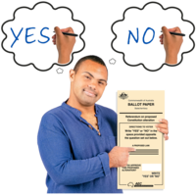

If we offer you the role, you will need a criminal record check. This is also ​called a DBS check. ​ This is a check to make sure you have ​not been in trouble with the police in a​ way that could affect your role.

**Keeping your details safe:**

We now need you to sign this form and to give us permission to complete the application process……

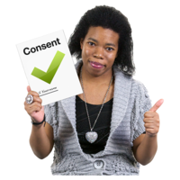



Date:

Signature:

I understand that The Elfrida Society will need to keep my personal details private and according to data protection rules.

|  |
| --- |
|  |

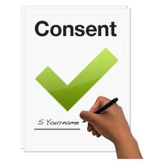

Please tick to agree.

There are clear rules about how organisations keep people’s personal information. These rules are called the General Data Protection Regulations or GDPR.

The rules give people rights about how organisations keep their personal information.

The Elfrida Society is fully committed to follow the GDPR rules and procedures to ensure that the rights of its service users, staff and volunteers are protected. Everyone working with the organisation must obey these rules and procedures.